In this Homework we dissected and parsed through data to determine which of the two types of schooling methods were more ideal. Namely between Charter or District. While the data shows distinct differences between the two types of educational institutions we can infer a great deal of information from a few specific sources.   
  
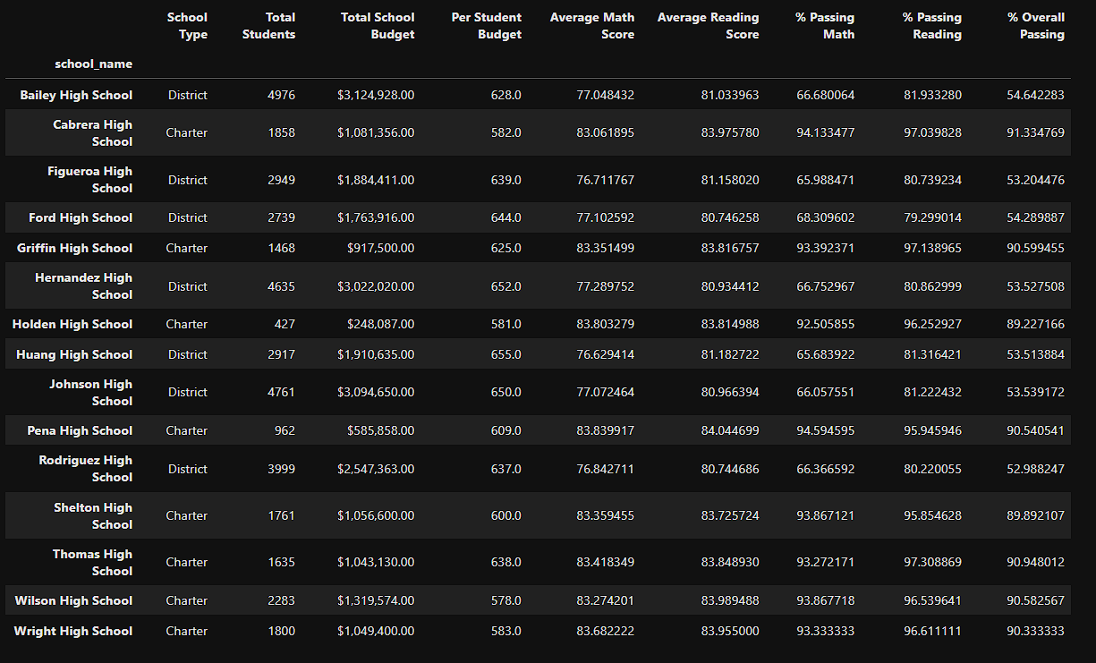

While we see District learning centers tend to have a larger student population as well as budgets, Charter schools tend to have fewer students and smaller budgets. Yet at times we see that their scores are higher than district schools.  
  
This can be an indication of several things, some more easily provable and some more inferred. First, we know that Public School Districts get most of their funds from local and federal taxes and or grants. Charter schools often gain their revenue through donations and or tuition from the families of students.

The disparity between the two different systems in terms of the grade differential is something we can attribute to the different class sizes. Public schools have larger classes whereas Character schools have smaller classes, namely by total student population. Teachers at Charter schools would have fewer students to contend with, while at Public Schools Teachers would be cycling classes of two dozen or more every hour or more.

The smaller class sizes of the Charter schools would lead to better performance in their academic scores with the Teaching staff having fewer students to cycle through lessons, also leading to a lesser amount of faculty burn out. Whereas larger class size and the accumulated stresses involved with larger populations, may cause a higher trend of faculty burn out as well as negligent course work.